WEEK 2:
1.
import pandas as pd
df=pd.read_csv("placement_dataset.csv")
import matplotlib.pyplot as plt
import seaborn as sns
plt.figure(figsize=(6,4))
sns.countplot(data=df, x="Branch")
plt.title("Placement Count by Branch")
plt.xlabel("Branch")
plt.ylabel("Count")
plt.show()
OUTPUT:
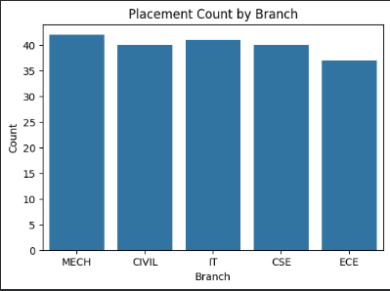
2.
import pandas as pd
df=pd.read_csv("placement_dataset.csv")
import matplotlib.pyplot as plt
import seaborn as sns
plt.figure(figsize=(6,4))
plt.hist(df["CGPA"].dropna(),
bins=15,
color="skyblue",
edgecolor="black")
plt.title("CGPA Distribution")
plt.xlabel("CGPA")
plt.ylabel("Frequency")
plt.show()
OUTPUT:
